Sending Alert Message

To play an alerting sound we need to install **"playsound"** library.

To install this library, open anaconda prompt and execute the below command.

Type **“pip install playsound”** click enter. Combining all codes

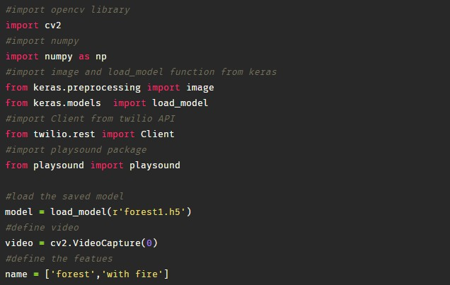

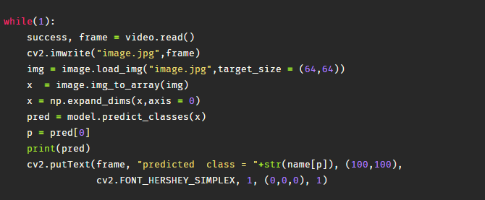

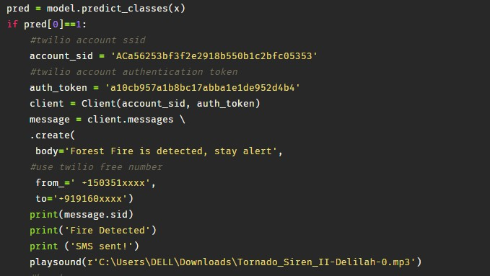

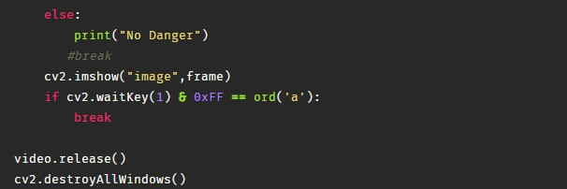

Once you run the above code, after loading your model, and the label names (classes) that you have considered in the project, and also the authentication token and Account SID from Twilio, This will open one video frame pop up on your desktop/laptop screen.

Now we provide with different test images of a forest fire or normal forest images, the model detects, if there is any forest fire in the video stream. If the forest fire is detected then an alert message will be sent to higher authorities and with a sound, else it returns no danger.

You can see the output in the below images. You can see the output in the console.

